

**Task1 Ijobs**

By: Laila Magdy Mansour

Submitted to:

Mr. Sameh Zaghloul

Mr. Labib Farag

Mr. Hesham El Badawi

Date 3/1/2019

**Draft Submission Dates**

|  |  |  |
| --- | --- | --- |
| **Draft** | **Date** | **Update** |
| First draft | 27/12/2018 |  |
| Final draft | 3/1/2019 |  |
|  |  |  |
|  |  |  |
|  |  |  |
|  |  |  |
|  |  |  |

Table of Contents

1. Introduction 4

2. Conclusion 4

# Introduction

***I-Class diagram:***

: 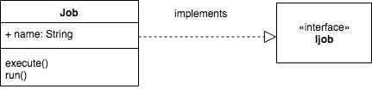

***II-Sequence Diagram***

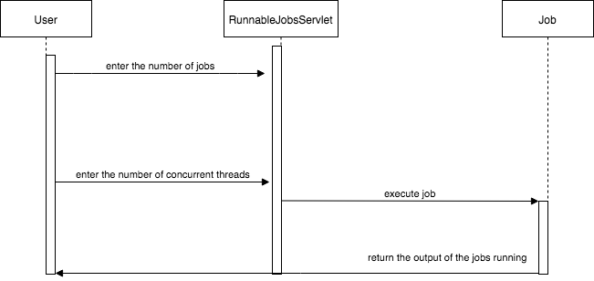

***Evaluation***

